**MySQL Subquery - Exercises, Practice, Solution**

1. Write a [MySQL](https://www.w3resource.com/mysql-exercises/subquery-exercises/) query to find the name (first_name, last_name) and the salary of the employees who have a higher salary than the employee whose last_name='Bull'.

[SELECT](http://localhost/phpmyadmin/url.php?url=https://dev.mysql.com/doc/refman/8.0/en/select.html) FIRST_NAME,LAST_NAME,SALARY FROM employees WHERE ([SELECT](http://localhost/phpmyadmin/url.php?url=https://dev.mysql.com/doc/refman/8.0/en/select.html) SALARY FROM employees WHERE LAST_NAME = 'Bull');

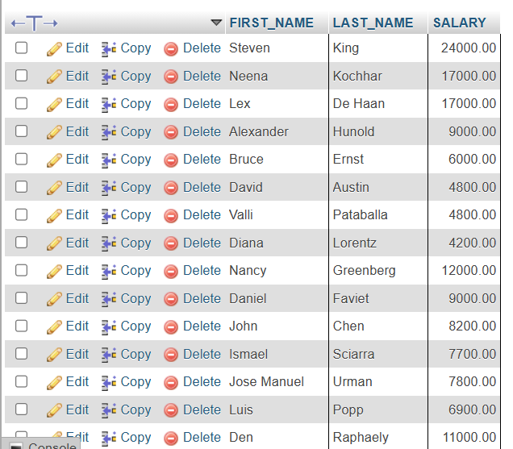

1. Write a [MySQL](https://www.w3resource.com/mysql-exercises/subquery-exercises/) query to find the name (first_name, last_name) of all employees who works in the IT department.

[SELECT](http://localhost/phpmyadmin/url.php?url=https://dev.mysql.com/doc/refman/8.0/en/select.html) FIRST_NAME,LAST_NAME FROM employees WHERE DEPARTMENT_ID [IN](http://localhost/phpmyadmin/url.php?url=https://dev.mysql.com/doc/refman/8.0/en/comparison-operators.html%23function_in)([SELECT](http://localhost/phpmyadmin/url.php?url=https://dev.mysql.com/doc/refman/8.0/en/select.html) DEPARTMENT_ID FROM departments WHERE DEPARTMENT_NAME='IT');

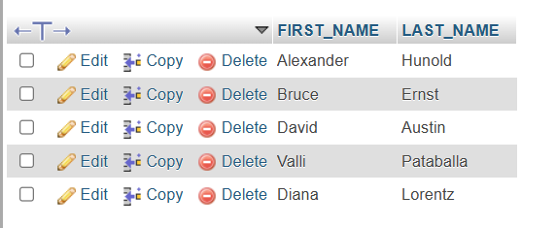

1. Write a [MySQL](https://www.w3resource.com/mysql-exercises/subquery-exercises/) query to find the name (first_name, last_name) of the employees who have a manager and worked in a USA based department.

[SELECT](http://localhost/phpmyadmin/url.php?url=https://dev.mysql.com/doc/refman/8.0/en/select.html) FIRST_NAME,LAST_NAME FROM employees WHERE MANAGER_ID [IN](http://localhost/phpmyadmin/url.php?url=https://dev.mysql.com/doc/refman/8.0/en/comparison-operators.html%23function_in)([SELECT](http://localhost/phpmyadmin/url.php?url=https://dev.mysql.com/doc/refman/8.0/en/select.html) EMPLOYEE_ID FROM employees WHERE DEPARTMENT_ID [IN](http://localhost/phpmyadmin/url.php?url=https://dev.mysql.com/doc/refman/8.0/en/comparison-operators.html%23function_in)([SELECT](http://localhost/phpmyadmin/url.php?url=https://dev.mysql.com/doc/refman/8.0/en/select.html) DEPARTMENT_ID FROM departments WHERE LOCATION_ID [IN](http://localhost/phpmyadmin/url.php?url=https://dev.mysql.com/doc/refman/8.0/en/comparison-operators.html%23function_in)([SELECT](http://localhost/phpmyadmin/url.php?url=https://dev.mysql.com/doc/refman/8.0/en/select.html) LOCATION_ID FROM locations WHERE COUNTRY_ID='US')));

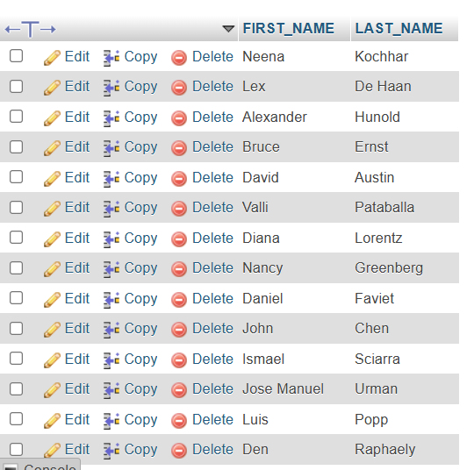

1. **Write a**[**MySQL**](https://www.w3resource.com/mysql-exercises/subquery-exercises/)**query to find the name (first_name, last_name) of the employees who are managers.**

[SELECT](http://localhost/phpmyadmin/url.php?url=https://dev.mysql.com/doc/refman/8.0/en/select.html) FIRST_NAME,LAST_NAME FROM employees WHERE MANAGER_ID [IN](http://localhost/phpmyadmin/url.php?url=https://dev.mysql.com/doc/refman/8.0/en/comparison-operators.html%23function_in)([SELECT](http://localhost/phpmyadmin/url.php?url=https://dev.mysql.com/doc/refman/8.0/en/select.html) MANAGER_ID FROM employees);

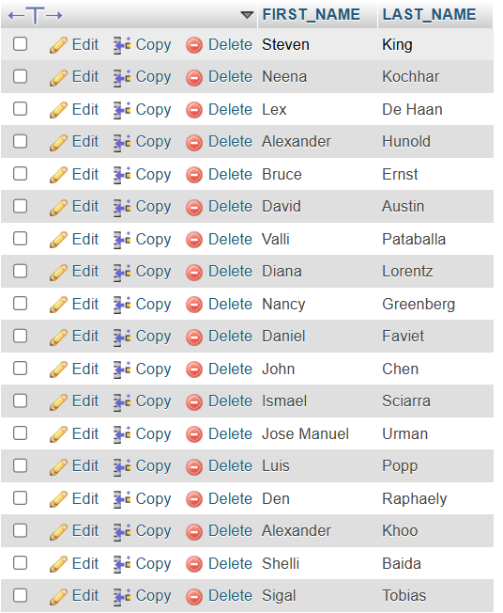

1. **Write a**[**MySQL**](https://www.w3resource.com/mysql-exercises/subquery-exercises/)**query to find the name (first_name, last_name), and salary of the employees whose salary is greater than the average salary.**

[**SELECT**](http://localhost/phpmyadmin/url.php?url=https://dev.mysql.com/doc/refman/8.0/en/select.html)**FIRST_NAME,LAST_NAME,SALARY FROM employees WHERE SALARY>(**[**SELECT**](http://localhost/phpmyadmin/url.php?url=https://dev.mysql.com/doc/refman/8.0/en/select.html)[**AVG**](http://localhost/phpmyadmin/url.php?url=https://dev.mysql.com/doc/refman/8.0/en/aggregate-functions.html%23function_avg)**(SALARY) FROM employees );**

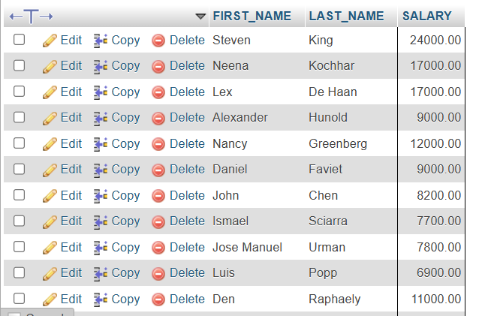

1. **Write a**[**MySQL**](https://www.w3resource.com/mysql-exercises/subquery-exercises/)**query to find the name (first_name, last_name), and salary of the employees whose salary is equal to the minimum salary for their job grade..**

[**SELECT**](http://localhost/phpmyadmin/url.php?url=https://dev.mysql.com/doc/refman/8.0/en/select.html)**FIRST_NAME, LAST_NAME, SALARY FROM employees WHERE employees.SALARY = (**[**SELECT**](http://localhost/phpmyadmin/url.php?url=https://dev.mysql.com/doc/refman/8.0/en/select.html)**MIN_SALARY FROM jobs WHERE employees.JOB_ID = jobs.JOB_ID);**



1. **Write a**[**MySQL**](https://www.w3resource.com/mysql-exercises/subquery-exercises/)**query to find the name (first_name, last_name), and salary of the employees who earns more than the average salary and works in any of the IT departments.**

[**SELECT**](http://localhost/phpmyadmin/url.php?url=https://dev.mysql.com/doc/refman/8.0/en/select.html)**FIRST_NAME, LAST_NAME, SALARY FROM employees WHERE DEPARTMENT_ID**[**IN**](http://localhost/phpmyadmin/url.php?url=https://dev.mysql.com/doc/refman/8.0/en/comparison-operators.html%23function_in)**(**[**SELECT**](http://localhost/phpmyadmin/url.php?url=https://dev.mysql.com/doc/refman/8.0/en/select.html)**DEPARTMENT_ID FROM departments WHERE DEPARTMENT_NAME**[**LIKE**](http://localhost/phpmyadmin/url.php?url=https://dev.mysql.com/doc/refman/8.0/en/string-comparison-functions.html%23operator_like)**'IT%')**[**AND**](http://localhost/phpmyadmin/url.php?url=https://dev.mysql.com/doc/refman/8.0/en/logical-operators.html%23operator_and)**SALARY > (**[**SELECT**](http://localhost/phpmyadmin/url.php?url=https://dev.mysql.com/doc/refman/8.0/en/select.html)[**AVG**](http://localhost/phpmyadmin/url.php?url=https://dev.mysql.com/doc/refman/8.0/en/aggregate-functions.html%23function_avg)**(SALARY) FROM employees);**



1. **Write a**[**MySQL**](https://www.w3resource.com/mysql-exercises/subquery-exercises/)**query to find the name (first_name, last_name), and salary of the employees who earns more than the earning of Mr. Bell.**

[**SELECT**](http://localhost/phpmyadmin/url.php?url=https://dev.mysql.com/doc/refman/8.0/en/select.html)**FIRST_NAME, LAST_NAME, SALARY FROM employees WHERE SALARY > (**[**SELECT**](http://localhost/phpmyadmin/url.php?url=https://dev.mysql.com/doc/refman/8.0/en/select.html)**SALARY FROM employees WHERE LAST_NAME = 'Bell') ORDER BY FIRST_NAME;**

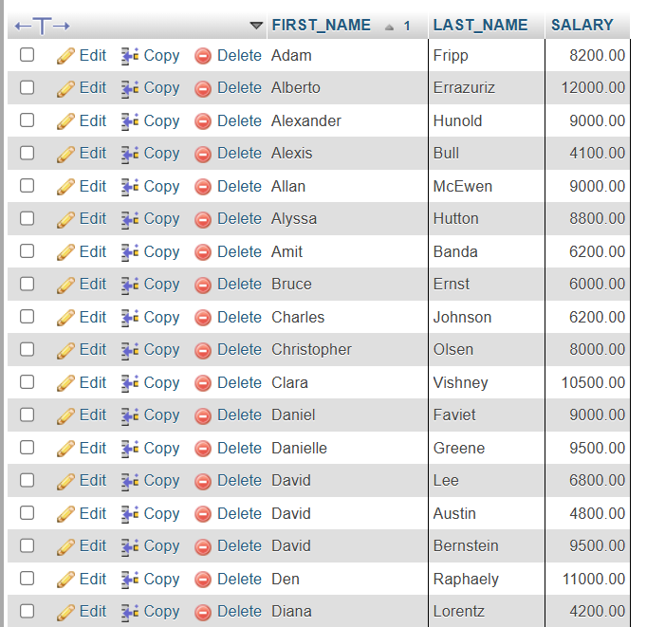

1. **Write a**[**MySQL**](https://www.w3resource.com/mysql-exercises/subquery-exercises/)**query to find the name (first_name, last_name), and salary of the employees who earn the same salary as the minimum salary for all departments.**

[**SELECT**](http://localhost/phpmyadmin/url.php?url=https://dev.mysql.com/doc/refman/8.0/en/select.html)**FIRST_NAME, LAST_NAME, SALARY FROM employees WHERE SALARY = (**[**SELECT**](http://localhost/phpmyadmin/url.php?url=https://dev.mysql.com/doc/refman/8.0/en/select.html)[**MIN**](http://localhost/phpmyadmin/url.php?url=https://dev.mysql.com/doc/refman/8.0/en/aggregate-functions.html%23function_min)**(SALARY) FROM employees);**



1. **Write a**[**MySQL**](https://www.w3resource.com/mysql-exercises/subquery-exercises/)**query to find the name (first_name, last_name), and salary of the employees whose salary is greater than the average salary of each department.**

[**SELECT**](http://localhost/phpmyadmin/url.php?url=https://dev.mysql.com/doc/refman/8.0/en/select.html)**\* FROM employees WHERE SALARY> ALL(**[**SELECT**](http://localhost/phpmyadmin/url.php?url=https://dev.mysql.com/doc/refman/8.0/en/select.html)[**AVG**](http://localhost/phpmyadmin/url.php?url=https://dev.mysql.com/doc/refman/8.0/en/aggregate-functions.html%23function_avg)**(SALARY) FROM employees GROUP BY DEPARTMENT_ID);**



1. **Write a**[**MySQL**](https://www.w3resource.com/mysql-exercises/subquery-exercises/)**query to find the name (first_name, last_name) and salary of the employees who earn a salary that is higher than the salary of all the Shipping Clerk (JOB_ID = 'SH_CLERK'). Sort the results of the salary of the lowest to highest.**

[**SELECT**](http://localhost/phpmyadmin/url.php?url=https://dev.mysql.com/doc/refman/8.0/en/select.html)**FIRST_NAME,LAST_NAME,SALARY FROM employees WHERE SALARY> ALL (**[**SELECT**](http://localhost/phpmyadmin/url.php?url=https://dev.mysql.com/doc/refman/8.0/en/select.html)**SALARY FROM employees WHERE JOB_ID = 'SH_CLERK');**

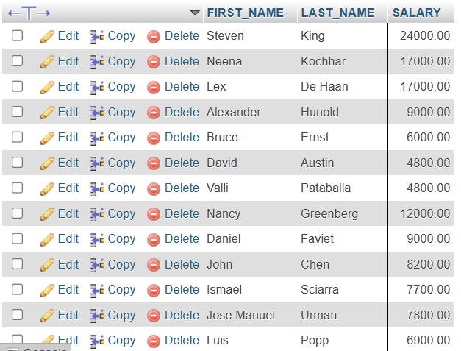

1. **Write a**[**MySQL**](https://www.w3resource.com/mysql-exercises/subquery-exercises/)**query to find the name (first_name, last_name) of the employees who are not supervisors.**

[**SELECT**](http://localhost/phpmyadmin/url.php?url=https://dev.mysql.com/doc/refman/8.0/en/select.html)**b.FIRST_NAME, b.LAST_NAME FROM employees b WHERE**[**NOT**](http://localhost/phpmyadmin/url.php?url=https://dev.mysql.com/doc/refman/8.0/en/logical-operators.html%23operator_not)**EXISTS (**[**SELECT**](http://localhost/phpmyadmin/url.php?url=https://dev.mysql.com/doc/refman/8.0/en/select.html)**'X' FROM employees a WHERE a.MANAGER_ID = b.EMPLOYEE_ID);**

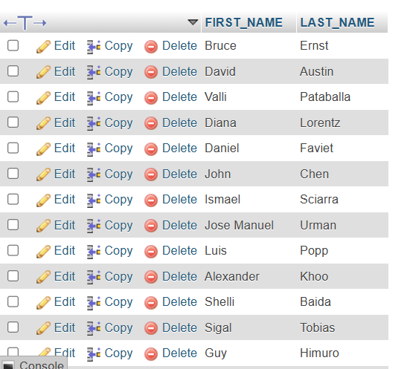

1. **Write a**[**MySQL**](https://www.w3resource.com/mysql-exercises/subquery-exercises/)**query to display the employee ID, first name, last name, and department names of all employees.**

[**SELECT**](http://localhost/phpmyadmin/url.php?url=https://dev.mysql.com/doc/refman/8.0/en/select.html)**EMPLOYEE_ID, FIRST_NAME, LAST_NAME, -- Subquery to fetch the department name for each employee's department_id (**[**SELECT**](http://localhost/phpmyadmin/url.php?url=https://dev.mysql.com/doc/refman/8.0/en/select.html)**DEPARTMENT_NAME FROM departments d -- Joining the employees table with the departments table based on the department_id WHERE e.DEPARTMENT_ID = d.DEPARTMENT_ID) departments -- Selecting data from the employees table, aliasing it as 'e' FROM employees e ORDER BY departments;**

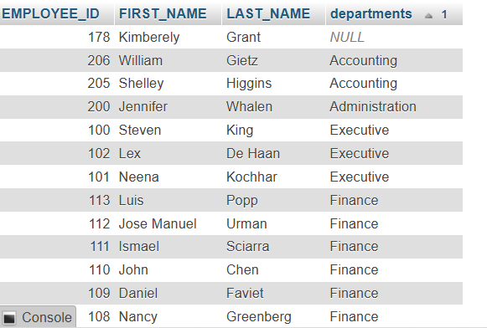

1. **Write a MySQL query to display the employee ID, first name, last name, salary of all employees whose salary is above average for their departments.**

[**SELECT**](http://localhost/phpmyadmin/url.php?url=https://dev.mysql.com/doc/refman/8.0/en/select.html)**EMPLOYEE_ID, FIRST_NAME, LAST_NAME FROM employees AS A WHERE SALARY> (**[**SELECT**](http://localhost/phpmyadmin/url.php?url=https://dev.mysql.com/doc/refman/8.0/en/select.html)[**AVG**](http://localhost/phpmyadmin/url.php?url=https://dev.mysql.com/doc/refman/8.0/en/aggregate-functions.html%23function_avg)**(SALARY) FROM employees WHERE DEPARTMENT_ID = A.DEPARTMENT_ID);**

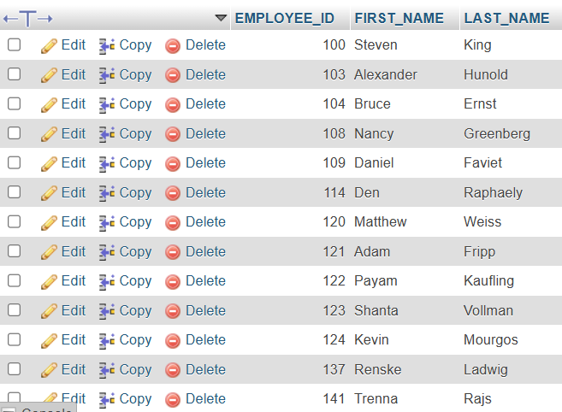

1. **Write a MySQL query to fetch even numbered records from employees table.**

[**SELECT**](http://localhost/phpmyadmin/url.php?url=https://dev.mysql.com/doc/refman/8.0/en/select.html)**i, EMPLOYEE_ID FROM (**[**SELECT**](http://localhost/phpmyadmin/url.php?url=https://dev.mysql.com/doc/refman/8.0/en/select.html)**@i := @i + 1 AS i, EMPLOYEE_ID FROM employees) a WHERE**[**MOD**](http://localhost/phpmyadmin/url.php?url=https://dev.mysql.com/doc/refman/8.0/en/mathematical-functions.html%23function_mod)**(a.i, 2) = 0;**

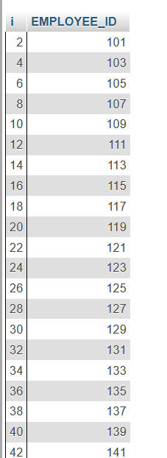

1. **Write a MySQL query to find the 5th maximum salary in the employees table.**

[**SELECT**](http://localhost/phpmyadmin/url.php?url=https://dev.mysql.com/doc/refman/8.0/en/select.html)**DISTINCT SALARY FROM employees e1 WHERE 5 = (**[**SELECT**](http://localhost/phpmyadmin/url.php?url=https://dev.mysql.com/doc/refman/8.0/en/select.html)[**COUNT**](http://localhost/phpmyadmin/url.php?url=https://dev.mysql.com/doc/refman/8.0/en/aggregate-functions.html%23function_count)**(DISTINCT SALARY) FROM employees e2 WHERE e2.SALARY >= e1.SALARY);**



1. **Write a MySQL query to find the 4th minimum salary in the employees table.**

[**SELECT**](http://localhost/phpmyadmin/url.php?url=https://dev.mysql.com/doc/refman/8.0/en/select.html)**DISTINCT SALARY FROM employees e1 WHERE 4 = (**[**SELECT**](http://localhost/phpmyadmin/url.php?url=https://dev.mysql.com/doc/refman/8.0/en/select.html)[**COUNT**](http://localhost/phpmyadmin/url.php?url=https://dev.mysql.com/doc/refman/8.0/en/aggregate-functions.html%23function_count)**(DISTINCT SALARY) FROM employees e2 WHERE e2.SALARY >= e1.SALARY);**



1. **Write a MySQL query to select last 10 records from a table.**

[**SELECT**](http://localhost/phpmyadmin/url.php?url=https://dev.mysql.com/doc/refman/8.0/en/select.html)**\* FROM (**[**SELECT**](http://localhost/phpmyadmin/url.php?url=https://dev.mysql.com/doc/refman/8.0/en/select.html)**\* FROM employees ORDER BY EMPLOYEE_ID DESC LIMIT 10 ) sub ORDER BY EMPLOYEE_ID ASC;**

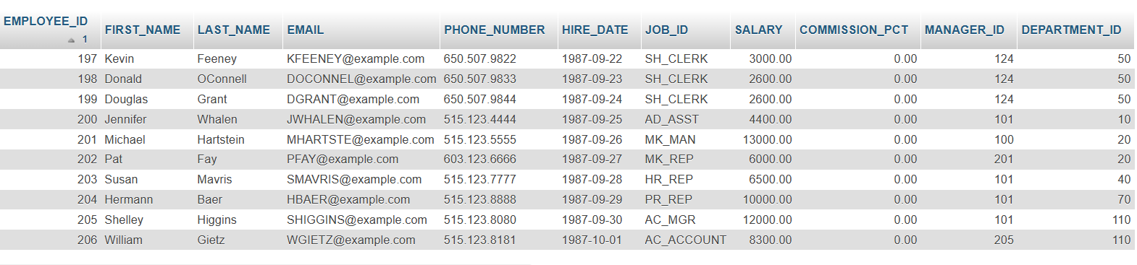

1. **Write a MySQL query to list the department ID and name of all the departments where no employee is working.**

[**SELECT**](http://localhost/phpmyadmin/url.php?url=https://dev.mysql.com/doc/refman/8.0/en/select.html)**\* FROM departments WHERE DEPARTMENT_ID**[**NOT**](http://localhost/phpmyadmin/url.php?url=https://dev.mysql.com/doc/refman/8.0/en/logical-operators.html%23operator_not)[**IN**](http://localhost/phpmyadmin/url.php?url=https://dev.mysql.com/doc/refman/8.0/en/comparison-operators.html%23function_in)**(**[**select**](http://localhost/phpmyadmin/url.php?url=https://dev.mysql.com/doc/refman/8.0/en/select.html)**DEPARTMENT_ID FROM employees);**

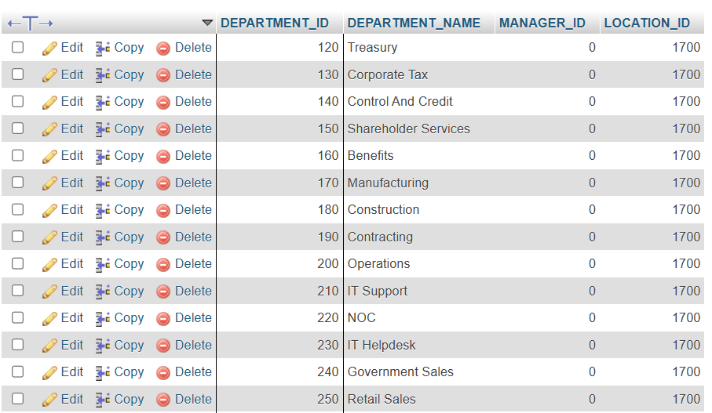

1. **Write a MySQL query to get 3 maximum salaries.**

[**SELECT**](http://localhost/phpmyadmin/url.php?url=https://dev.mysql.com/doc/refman/8.0/en/select.html)**DISTINCT SALARY FROM employees a WHERE 3 >= (**[**SELECT**](http://localhost/phpmyadmin/url.php?url=https://dev.mysql.com/doc/refman/8.0/en/select.html)[**COUNT**](http://localhost/phpmyadmin/url.php?url=https://dev.mysql.com/doc/refman/8.0/en/aggregate-functions.html%23function_count)**(DISTINCT SALARY) FROM employees b WHERE b.SALARY >= a.SALARY) ORDER BY a.SALARY DESC;**



1. **Write a MySQL query to get 3 minimum salaries.**

[**SELECT**](http://localhost/phpmyadmin/url.php?url=https://dev.mysql.com/doc/refman/8.0/en/select.html)**DISTINCT SALARY FROM employees a WHERE 3 >= (**[**SELECT**](http://localhost/phpmyadmin/url.php?url=https://dev.mysql.com/doc/refman/8.0/en/select.html)[**COUNT**](http://localhost/phpmyadmin/url.php?url=https://dev.mysql.com/doc/refman/8.0/en/aggregate-functions.html%23function_count)**(DISTINCT SALARY) FROM employees b WHERE b.SALARY <= a.SALARY) ORDER BY a.SALARY DESC;**



1. **Write a MySQL query to get nth max salaries of employees.**

[**SELECT**](http://localhost/phpmyadmin/url.php?url=https://dev.mysql.com/doc/refman/8.0/en/select.html)**\* FROM employees emp1 WHERE (1) = (**[**SELECT**](http://localhost/phpmyadmin/url.php?url=https://dev.mysql.com/doc/refman/8.0/en/select.html)[**COUNT**](http://localhost/phpmyadmin/url.php?url=https://dev.mysql.com/doc/refman/8.0/en/aggregate-functions.html%23function_count)**(DISTINCT(emp2.salary)) FROM employees emp2 WHERE emp2.SALARY > emp1.SALARY );**

